GUEST EVENT INFORMATION
Las Vegas Raiders vs. Dallas Cowboys | Thursday, November 25, 2021 | Kickoff: 3:30pm
WEATHER FORECAST
High………………………………………………………: 60°
Low……………………………………………………….: 36°
Chance of Rain………………………………………….: 14%

We are getting ready for game day here at AT&T Stadium with the Dallas Cowboys taking on the Las Vegas Raiders on Thursday, November 25th at 3:30pm. Below we have some items that we hope answer your questions for the event. If you do not see the answer to your question below, please call Guest Services at 817.892.4161.

GAMEDAY GIVEAWAYS
Rally Towels will be on every seat for each guest, courtesy of Miller Lite. And upon exit, grab an Aluminum Cup courtesy of Miller Lite and a Magnet Card courtesy of ShaveLogic!

SCAN IN & OUT FOR CLUB & SUITE GUESTS
All Club and Suite guests must have their ticket scanned when they are entering or exiting the Club and Suite areas. Be sure to have your ticket with you so that the stadium staff can scan each time you enter and exit the Club and Suite areas.

MOBILE LOCKER UNITS
AT&T Stadium will be utilizing mobile lockers to provide secure, convenient storage options for guests who have bags that do not comply with the stadium bag policy. These storage areas are located within AT&T Stadium Parking Lots 5 & 9. Locker rental fee is $20.00 (credit only).

DALLAS COWBOYS UNITED PRESENTED BY GLOBE LIFE
Dallas Cowboys United will be selling memberships in the AT&T East Plaza that have packages including car flags, license plate frames, backpacks, clear bags, stadium cups and a kid’s backpack with a miniature football. To join Dallas Cowboys United, please visit http://dallascowboys.com/united

MAIN EVENT FAMILY END ZONE
Cowboys Nation be sure to stop by the Main Event Family End Zone, located on the AT&T East Plaza, to have fun before the game! You will find arcade and virtual reality games, fun family activities, and giveaways to make your game day memories even better.

NEW MILLER LITEHOUSE OPEN
Come check out the new Miler LiteHouse before and after every Dallas Cowboys Home Game. The LiteHouse will be filled with unique entertainment, live music on the stage, a celebrity kickoff toast before each game and $5 12oz Miller Lite Beers all day long! Visit https://attstadium.com/millerlitehouse/ for more information. Then stay 2 hours after the game for the Postgame Party with DJSC. This party is offered to all ticket holders and will start immediately following the game and lasts for 2 hours.

50/50 RAFFLE TEAMS
Guests will have the opportunity to purchase raffle tickets during the event, and a raffle drawing will be held at the end of the 3rd Quarter. Guests will split the total amount of money raised with the charity that will be featured at this game (split 50/50, i.e. “50/50 Raffle”). Kiosks for the 50/50 Raffle will be located in Ryan Club, AT&T Star Club, Choctaw Casino Club, American Airlines Lounge, Hall of Fame Concourses, Main Concourse Platforms & Upper Concourse Platforms.

POSTGAME RIDESHARE PICK-UP
AT&T Stadium Parking Lot 15 will be the rideshare pick-up location for every Dallas Cowboys home game during the 2021-22 Season.

TICKETING INFORMATION
Seating : Reserved Seating
Child Ticket Policy : Ages 1 & older require a ticket
Re-Entry Policy : Not Permitted

PARKING INFORMATION
AT&T Stadium Parking Lots Open : All AT&T Stadium Lots
RV / Overnight Parking Info : RV / Overnight Parking in Lot 14
RV Parking Opens: 11/24/21 at 8:00am
RV Parking Closes: 11/26/21 at 5:00pm
Day of Parking Locations : AT&T Stadium Lots as available. Credit Card & Mobile Pay Only
Parking Directions : www.attstadium.com

EVENT TIMELINE Subject to Change
AT&T Stadium Pro Shop Open : 8:00am
AT&T Stadium Parking Lots Open : 10:30am
AT&T Stadium North & South Ticket Office Open : 10:30am
Media Entrances Open : 11:30am
AT&T East Plaza & Miller LiteHouse Open : 11:30am
Entries D & J Open for DC United Fan Club : 1:00pm
Stadium Club Open : 12:30pm
Clubs & Suites Open : 1:30pm
All Stadium Entrances Open : 1:30pm
Kickoff : 3:30pm
Event End (Estimated) : 6:50pm
Stadium Closes (Estimated) : 7:50pm
Stadium Club Closes (Estimated) : 7:50pm
Postgame Activities End (Estimated) : 8:50pm

ADDITIONAL EVENT INFORMATION
Website……………………………….……… …………: www.attstadium.com
Guest Services Hotline………………………………...: 817.892.4161
Guest Text Messaging Service…………………….....: Text 972.945.3005
With Your Concern

An inherent risk of exposure to COVID-19 exists in any public place where people are present. COVID-19 is an extremely contagious disease that can lead to severe illness and death. According to the centers for disease control and prevention, senior citizens and those with underlying medical conditions are especially vulnerable. By entering the stadium and stadium grounds, you voluntarily assume all risks related to exposure to COVID-19. Please review the “Know Before You Go” Guidelines Here https://attstadium.com/safestadium/

KNOW BEFORE YOU GO

AT&T Stadium is committed to serving guests with disabilities. Our facilities are fully accessible and we provide a wide range of services and amenities for guests with special needs. Guests can receive more information by visiting one of our Guest Services Centers located on the concourse behind Sections 219, 244, 420 and 451. Animals are not permitted in AT&T Stadium with the exception of service animals and service animals in training. For more information, please contact the Guest Services Hotline at (817) 892-4161.

Accessibility

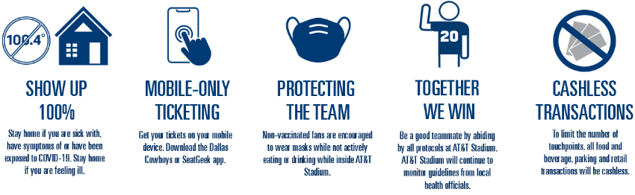

The Revised AT&T Stadium Bag Policy is in effect for this game. AT&T Stadium instituted the National Football League’s policy that limits the size and types of bags entering AT&T Stadium on event days. The policy is a league-wide initiative intended to enhance public safety for events at NFL stadiums across the country. The NFL strongly encourages fans to not bring any type of bags to the venue. However, should bags be needed, approved items include:
- Clear plastic, vinyl or PVC totes that do not exceed 12” x 6” x 12”
- Clear one-gallon re-sealable storage bags
- Small clutch purses/bags approximately the size of a hand – not to exceed 4.5” x 6.5” in size – with or without a handle or strap
Prohibited bags include, but are not limited to: purses larger than a clutch bag, coolers, briefcases, backpacks, fanny packs, cinch bags, seat cushions, luggage of any kind, computer bags and camera bags or any bag larger than the permissible size. For a detailed list of all prohibited and allowed items, visit http://attstadium.com. Due to security reasons, bags that are abandoned will be discarded of immediately.

AT&T Stadium Bag Policy in Effect

Bags, purses, outside alcohol, food items*, bottles, cans and beverage containers of any kind*, coolers*, weapons of any kind, laser pointers, footballs, signs or flags on sticks, noisemakers, tripods, monopods and cameras with lens larger than 3” (detachable or non-detachable), video cameras, chairs, stools or other seating devices. *Exceptions will be made for Guests with special medical needs.

Prohibited Items

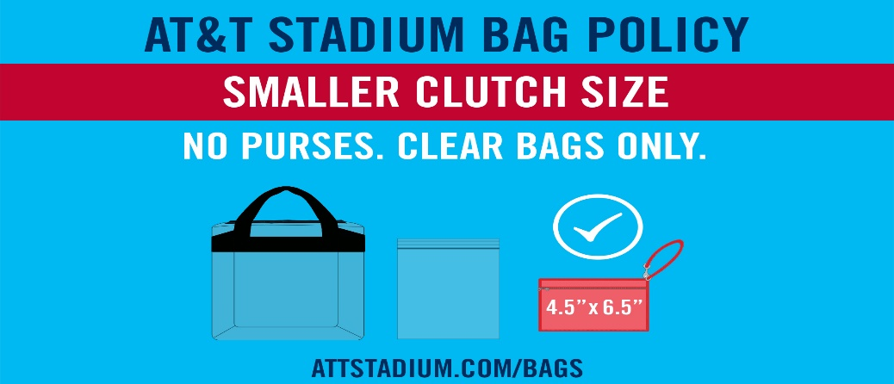
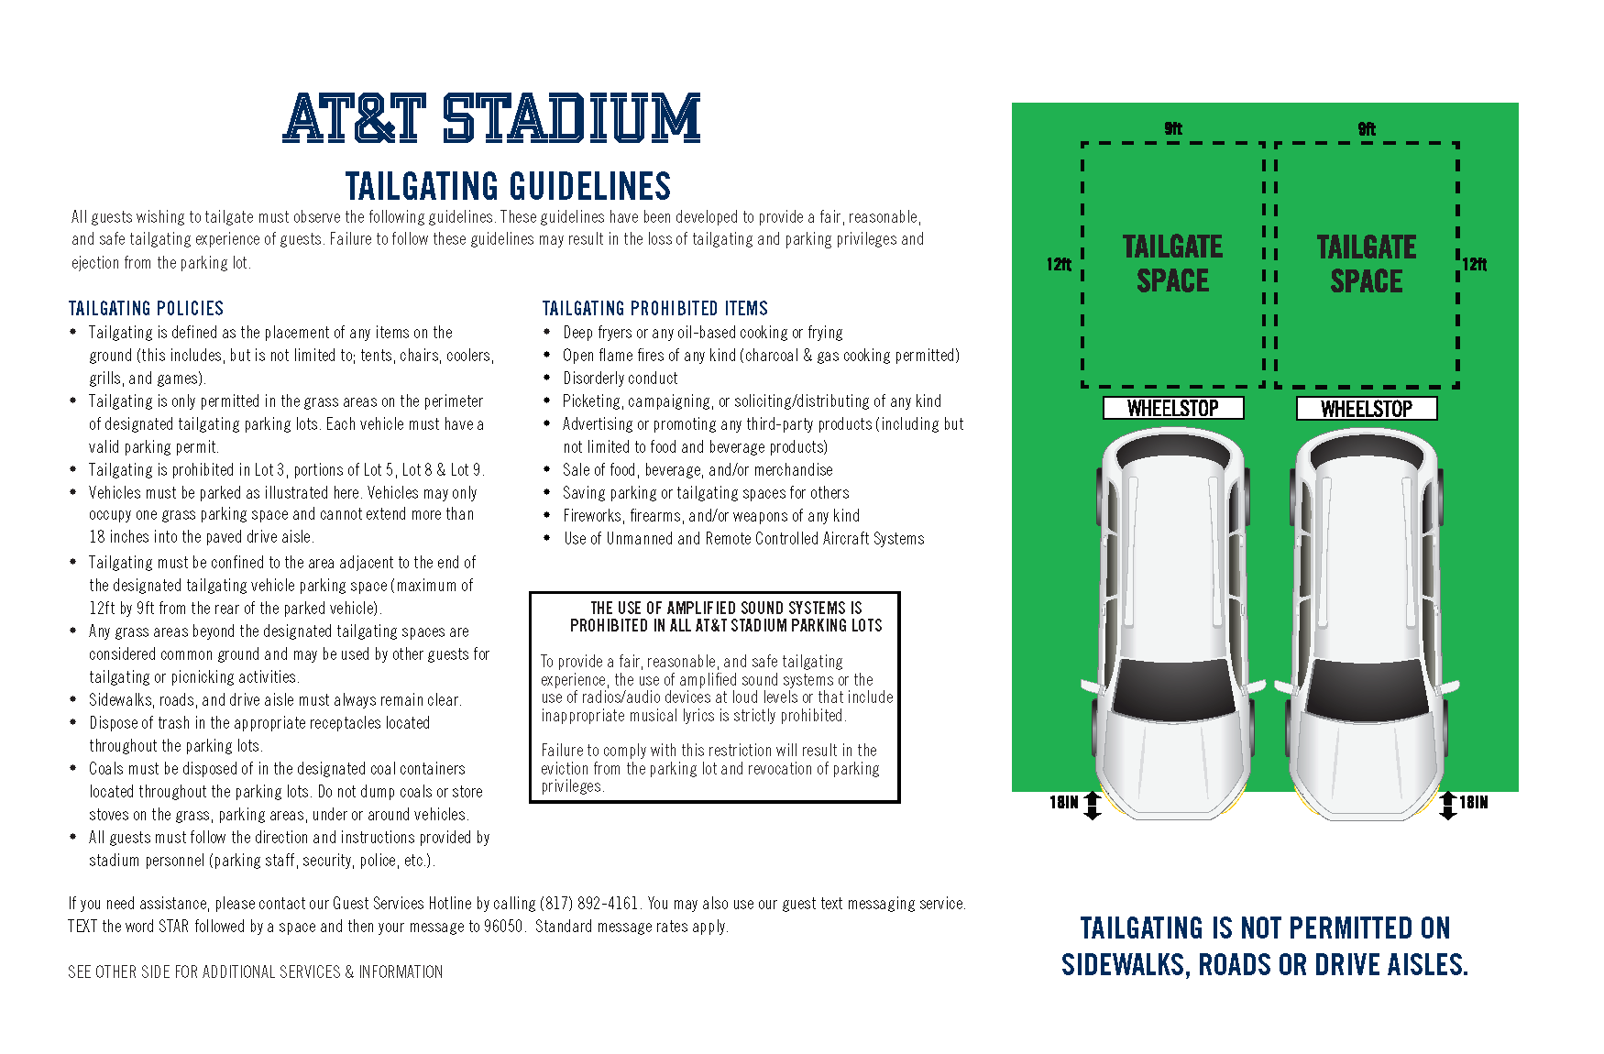

All guests entering AT&T Stadium are subject to a physical security screening of their person and accompanying items. The physical screening consists of a walkthrough metal detector sweep. Please remove cell phones or larger metal objects prior to screening. Guests who wish not to be screened by metal detector may elect a physical pat-down screening as an alternative. All other articles will be visually inspected. Items in sealed/wrapped boxes must be opened for inspection.

Security Screening

AT&T Stadium Management is committed to creating a safe, comfortable and enjoyable experience for our guests. Our staff will proactively support an environment free from the following behaviors: Abusive, foul or disruptive language and obscene gestures, intoxication or other signs of impairment related to alcohol consumption, fighting, taunting or threatening remarks or gestures, sitting in a location other than the guest’s ticketed seat, displays of affection not appropriate in a public setting, obscene or indecent clothing, any disruption to the progress of the event by the guest’s actions.

Code of Conduct

