GUEST EVENTINFORMATION

Monster Jam | Saturday, October 16,2021 | 7:00pm

**WEATHER FORECAST**

High………………………………………………………: 73⁰

Low……………………………………………………….: 53⁰

Chance of Rain………………………………………….: 0%

We are getting ready for event/game day here at AT&T Stadium with Monster Jam on Saturday, October 16, 2021. Below we have some items that we hope can answer your questions for the event. If you do not see the answer to your question below, please call our Guest Services Hotline at 817.892.4161. Enjoy the event!



**EVENT DESCRIPTION**

Monster Jam® returns to AT&T Stadium on Saturday, October 16th! Monster Jam® is an action-packed motorsport with world-class athletes locked in intense competitions of speed and skill. Witness heated rivalries, high-flying stunts and fierce head-to-head battles for the Event Championship. Engineered to perfection, these 12,000-pound monster trucks, including the legendary Grave Digger® and Monster Energy®, push all limits in Freestyle, Skills Challenge and Racing competitions. This is full-throttle family fun. This. Is. Monster Jam™.

**LOST & FOUND**

If you have lost an item at any point during the event or find an item you would like to turn in, report to our Guest Services Centers which are located behind sections 219 & 244.

**MOBILE LOCKER UNITS**

AT&T Stadium will be utilizing mobile lockers to provide secure, convenient storage options for guests who have bags that do not comply with the stadium bag policy. These storage areas are located within AT&T Stadium Parking Lot 5. Locker rental fee is $10.00, and all transactions are cashless.

**WI-FI**

AT&T provides free wi-fi services for all of its guests. Connect to attwifi in your list of available wi-fi networks. When prompted with the AT&T web page, click the checkbox that you agree to the Terms and Conditions of Service and then click connect.

**DALLAS COWBOYS APP**

Enhance your experience at the stadium by downloading the Dallas Cowboys App. You can view the event day schedule, use navigation maps to get around the stadium and see traffic routes, feel safe by being able to effectively notify security, and more!

**AT&T CELL PHONE CHARGING STATIONS**

Complimentary phone charging stations are locatedon the east main level platform, just inside the Entry C doors by the AT&T East Plaza. There are four stations, each with (12) individual lockers that are equipped with cables to charge all iPhone and Android devices. Guests should simply enter the letter “C,” followed by a unique code that will allow them to place their phone in the locker to charge. If a guest leaves their phone in the locker, or forgets their unique code, phones will be brought to the Guest Services Center at Section 244 where our staff can unlock the lockers with a key, or reunite the guest with their lost phone.

**POST EVENT RIDESHARE PICK-UP**

The West end of the Miller Lite West Plaza will be the dedicated location for all rideshare pick-ups for this event.

**TICKETING INFORMATION**

Seating : Reserved

Suite Sales Information : Contact 817-892-4470 for Suite Sales Department

Tickets On Sale at : [www.SeatGeek.com](http://www.SeatGeek.com)

Child Ticket Policy : Ages 2 & Up Require a Ticket

Re-Entry Policy : Not Permitted

**PARKING INFORMATION**

AT&T Stadium Parking Lots Open : All AT&T Stadium Lots

RV/ Overnight Parking Info : RV/ Overnight Parking in Lot 14. RV Parking Opens: 10/15/2021

RV Parking Closes: 10/17/2021

Day of Parking Locations : AT&T Stadium Lots as Available

AT&T Stadium Parking Cost : Credit Card & Mobile Pay Only $35 Car Parking $150 Bus / RV (Lot 14)

$125 Limo (Lot 11)

Parking Directions : [www.attstadium.com](http://www.attstadium.com)

**EVENT TIMELINE** *Subject to Change*

AT&T Stadium Pro Shop Open : 9:00am

AT&T Stadium Parking Lots Open : 2:00pm

AT&T Stadium North & South Ticket Offices Open : 2:00pm

Gates W1, W5 & W10 Open for Pit Party : 2:30pm

Pit Party Open : 2:30pm

All Stadium Entrances Open : 5:00pm

Pit Party Closes : 5:30pm

Event Start : 7:00pm

Event End (Estimated) : 9:30pm

Stadium Closes (Estimated) : 10:00pm

**ADDITIONAL EVENT INFORMATION**

Web Site……………………………….……………………: [www.attstadium.com/events](http://www.attstadium.com/events)

Guest Services Hotline…………………………………....: 817.892.4161

Guest Text Messaging Service……………….................: Text 972.945.3005

With Your Concerns

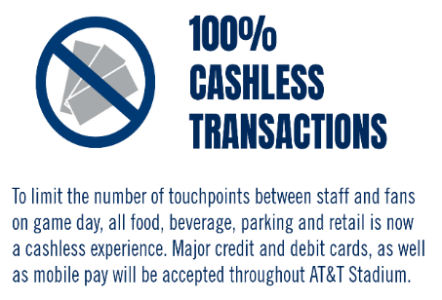

AT&T Stadium has implemented a series of health and sanitization policies and procedures and are following guidelines from the CDC, NFL, the State of Texas and local public safety and public health officials. Every fan plays an important role in facilitating a safe and low-risk environment at AT&T Stadium. Please visit the Safe Stadium information at [www.DallasCowboys.com/SafeStadium](http://www.DallasCowboys.com/SafeStadium)

**SAFE STADIUM**

**ADA/ Accessibility**

AT&T Stadium is committed to serving guests with disabilities. Our facilities are fully accessible and we provide a wide range of services and amenities for guests with special needs. Guests can receive more information by visiting one of our Guest Services Centers located on the concourse behind Sections 219 & 244. Animals are not permitted in AT&T Stadium with the exception of service animals and service animals in training. For more information, please contact the Guest Services Hotline at (817) 892-4161.

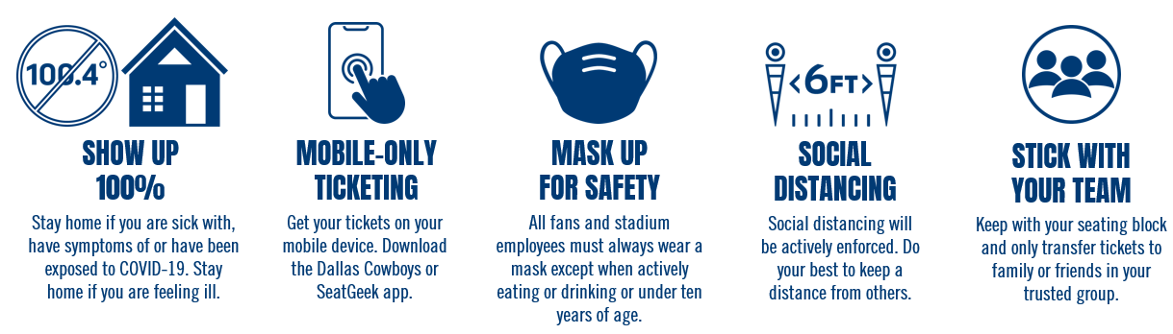

The Revised AT&T Stadium Bag Policy is in effect for this game. AT&T Stadium instituted the National Football League’s policy that limits the size and types of bags entering AT&T Stadium on event days. The policy is a league-wide initiative intended to enhance public safety for events at NFL stadiums across the country. The NFL strongly encourages fans to not bring any type of bags to the venue. However, should bags be needed, approved items include:

* Clear plastic, vinyl or PVC totes that do not exceed 12” x 6” x 12”
* Clear one-gallon re-sealable storage bags
* Small clutch purses/bags approximately the size of a hand – not to exceed 4.5” x 6.5” in size – with or without a handle or strap

Prohibited bags include, but are not limited to: purses larger than a clutch bag, coolers, briefcases, backpacks, fanny packs, cinch bags, seat cushions, luggage of any kind, computer bags and camera bags or any bag larger than the permissible size. For a detailed list of all prohibited and allowed items, visit <http://attstadium.com>. Due to security reasons, bags that are abandoned will be discarded of immediately.

**AT&T Stadium Bag Policy in Effect**

Bags, purses, outside alcohol, food items*, bottles, cans and beverage containers of any kind*, coolers*, weapons of any kind, laser pointers, footballs, signs or flags on sticks, noisemakers, tripods, monopods and cameras with lens larger than 3” (detachable or non-detachable), video cameras, chairs, stools or other seating devices. *Exceptions will be made for Guests with special medical needs.

**Prohibited Items**

All guests entering AT&T Stadium are subject to a physical security screening of their person and accompanying items. The physical screening consists of a walkthrough metal detector sweep. Please remove cell phones or larger metal objects prior to screening. Guests who wish not to be screened by metal detector may elect a physical pat-down screening as an alternative. All other articles will be visually inspected. Items in sealed/wrapped boxes must be opened for inspection.

**Security Screening**

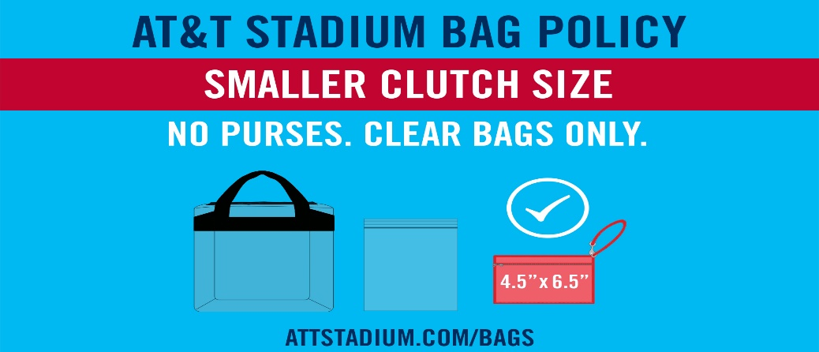

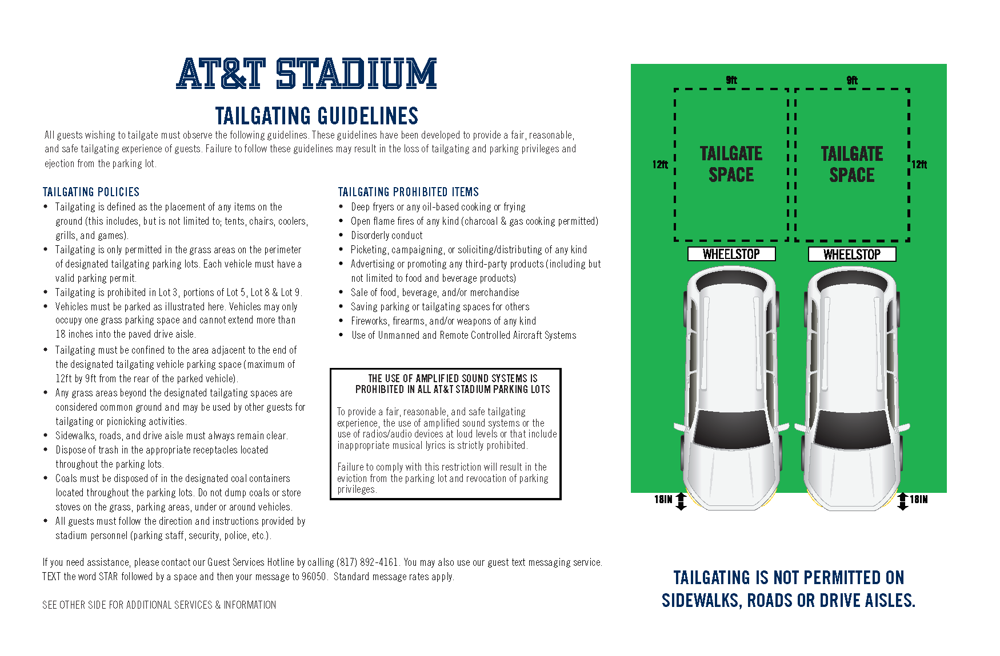

**Code of Conduct**

AT&T Stadium Management is committed to creating a safe, comfortable and enjoyable experience for our guests. Our staff will proactively support an environment free from the following behaviors: Abusive, foul or disruptive language and obscene gestures, intoxication or other signs of impairment related to alcohol consumption, fighting, taunting or threatening remarks or gestures, sitting in a location other than the guest’s ticketed seat, displays of affection not appropriate in a public setting, obscene or indecent clothing, any disruption to the progress of the event by the guest’s actions.