GUEST EVENT INFORMATION
2021 Southwest Classic: University of Arkansas University vs. Texas A&M University | Saturday, September 25, 2021 | Kickoff: 2:30pm
We are getting ready for event day here at AT&T Stadium for 2021 Southwest Classic featuring University of Arkansas vs Texas A&M University on Saturday, September 25, 2021. Below we have some items that we hope can answer your questions for the event. If you do not see the answer to your question below, please call our Guest Services Hotline at 817.892.4161. Enjoy the event!
WEATHER FORECAST
High………………………………………………………: 85°
Low……………………………………………………….: 60°
Chance of Rain………………………………………….: 0%

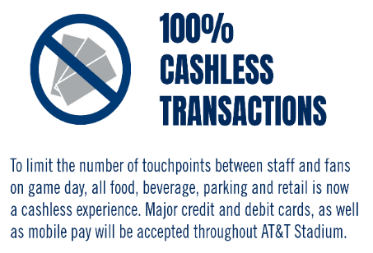
2021 SOUTHWEST CLASSIC
The annual Southwest Classic returns to AT&T Stadium on Saturday, September 25th. Don’t miss your chance to see the Arkansas Razorbacks take on the Texas A&M Aggies!

LOST & FOUND

If you have lost an item at any point during the event or find an item you would like to turn in, report to our Guest Services Centers which are located behind sections 219, 244, 420, & 451.

MOBILE LOCKER UNITS

AT&T Stadium will be utilizing mobile lockers to provide secure, convenient storage options for guests who have bags that do not comply with the stadium bag policy. These storage areas are located within AT&T Stadium Parking Lots 5 & 9. Locker rental fee is $20.00, and all transactions are cashless.

DALLAS COWBOYS APP

Enhance your experience at the stadium by downloading the Dallas Cowboys App. You can view the event day schedule, use navigation maps to get around the stadium and see traffic routes, feel safe by being able to effectively notify security, and more!

POST-EVENT RIDESHARE PICK-UP

The Taxi Queue Lane, outside the West end of the Miller LiteHouse will be the rideshare pick-up location for the 2021 Allstate Kickoff Classic.

TICKETING INFORMATION
Seating : Reserved Seating
Suite Sales Information : Contact (817) 892-4470 for the Suite Sales Department
Tickets On Sale at : www.SeatGeek.com
Child Ticket Policy : Everyone, Regardless of Age Requires a Ticket
Re-Entry Policy : Not Permitted

PARKING INFORMATION
AT&T Stadium Parking Lots Open : All AT&T Stadium Lots
RV/ Overnight Parking Info : RV / Overnight Parking in Lot 14 RV Parking Opens: 9/24/2021
RV Parking Closes: 9/26/2021
Day of Parking Locations : AT&T Stadium Lots as available
AT&T Stadium Parking Cost : Credit Card & Mobile Pay Only $50 Car Parking $150 Bus / RV (Lot 14)
$125 Limo (Lot 11)
Parking Directions at : www.attstadium.com

EVENT TIMELINE Subject to Change
AT&T Stadium Pro Shop Open : 9:00am
Media Entrance Open : 10:30am
Media Will Call Open (North Ticket Office) : 10:30am
AT&T Stadium Parking Lots Open : 10:30am
AT&T Stadium North & South Ticket Offices Open : 10:30am
AT&T East Plaza & Miller LiteHouse Open : 12:30pm
Clubs & Suites Open : 12:30pm
All Stadium Entrances Open : 12:.30pm
Kickoff : 2:30pm
Event End (Estimated) : 5:30pm
Stadium Closes (Estimated) : 6:30pm

ADDITIONAL EVENT INFORMATION

Website : www.attstadium.com
Guest Services Hotline : 817.892.4161
Guest Text Messaging Service : Text 972.435.0505
With Your Concerns

An inherent risk of exposure to COVID-19 exists in any public place where people are present. COVID-19 is an extremely contagious disease that can lead to severe illness and death. According to the centers for disease control and prevention, senior citizens and those with underlying medical conditions are especially vulnerable. By entering the stadium and stadium grounds, you voluntarily assume all risks related to exposure to COVID-19. Please review the “Know Before You Go” Guidelines Here https://attstadium.com/safestadium/

KNOW BEFORE YOU GO

ADA/ Accessibility

AT&T Stadium is committed to serving guests with disabilities. Our facilities are fully accessible, and we provide a wide range of services and amenities for guests with special needs. Guests can receive more information by visiting one of our Guest Services Centers located on the concourse behind Sections 219, 244, 420 and 451. Animals are not permitted in AT&T Stadium with the exception of service animals and service animals in training. For more information, please contact Guest Services at (817) 892-4161.

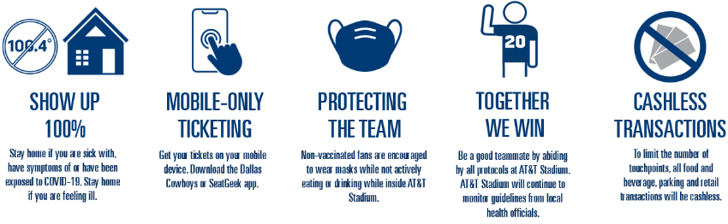

The AT&T Stadium Bag Policy is in effect for this event. AT&T Stadium instituted the National Football League’s policy that limits the size and types of bags entering AT&T Stadium on event days. The policy is a league-wide initiative intended to enhance public safety for events at NFL stadiums across the country. The NFL strongly encourages fans to not bring any type of bags to the venue. However, should bags be needed, approved items include:
- Clear plastic, vinyl or PVC totes that do not exceed 12” x 6” x 12”
- Clear one-gallon re-sealable storage bags
- Small clutch purses/bags approximately the size of a hand – not to exceed 4.5” x 6.5” in size – with or without a handle or strap
Prohibited bags include, but are not limited to: purses larger than a clutch bag, coolers, briefcases, backpacks, fanny packs, cinch bags, seat cushions, luggage of any kind, computer bags and camera bags or any bag larger than the permissible size. For a detailed list of all prohibited and allowed items, visit www.attstadium.com. Due to security reasons, bags that are abandoned will be discarded of immediately.

AT&T Stadium Bag Policy in Effect

Bags, purses, outside alcohol, food items*, bottles, cans and beverage containers of any kind*, coolers*, weapons of any kind, laser pointers, footballs, signs or flags on sticks, noisemakers, tripods, monopods and cameras with lens larger than 3” (detachable or non-detachable), video cameras, chairs, stools or other seating devices. *Exceptions will be made for guests with special medical needs.

Prohibited Items

All guests entering AT&T Stadium are subject to a physical security screening of their person and accompanying items. The physical screening consists of a walkthrough metal detector sweep. Please remove cell phones or larger metal objects prior to screening. Guests who wish not to be screened by metal detector may elect a physical pat-down screening as an alternative. All other articles will be visually inspected. Items in sealed/wrapped boxes must be opened for inspection.

Security Screening

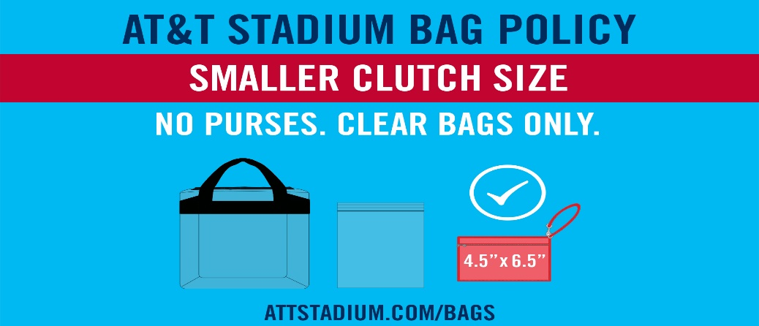

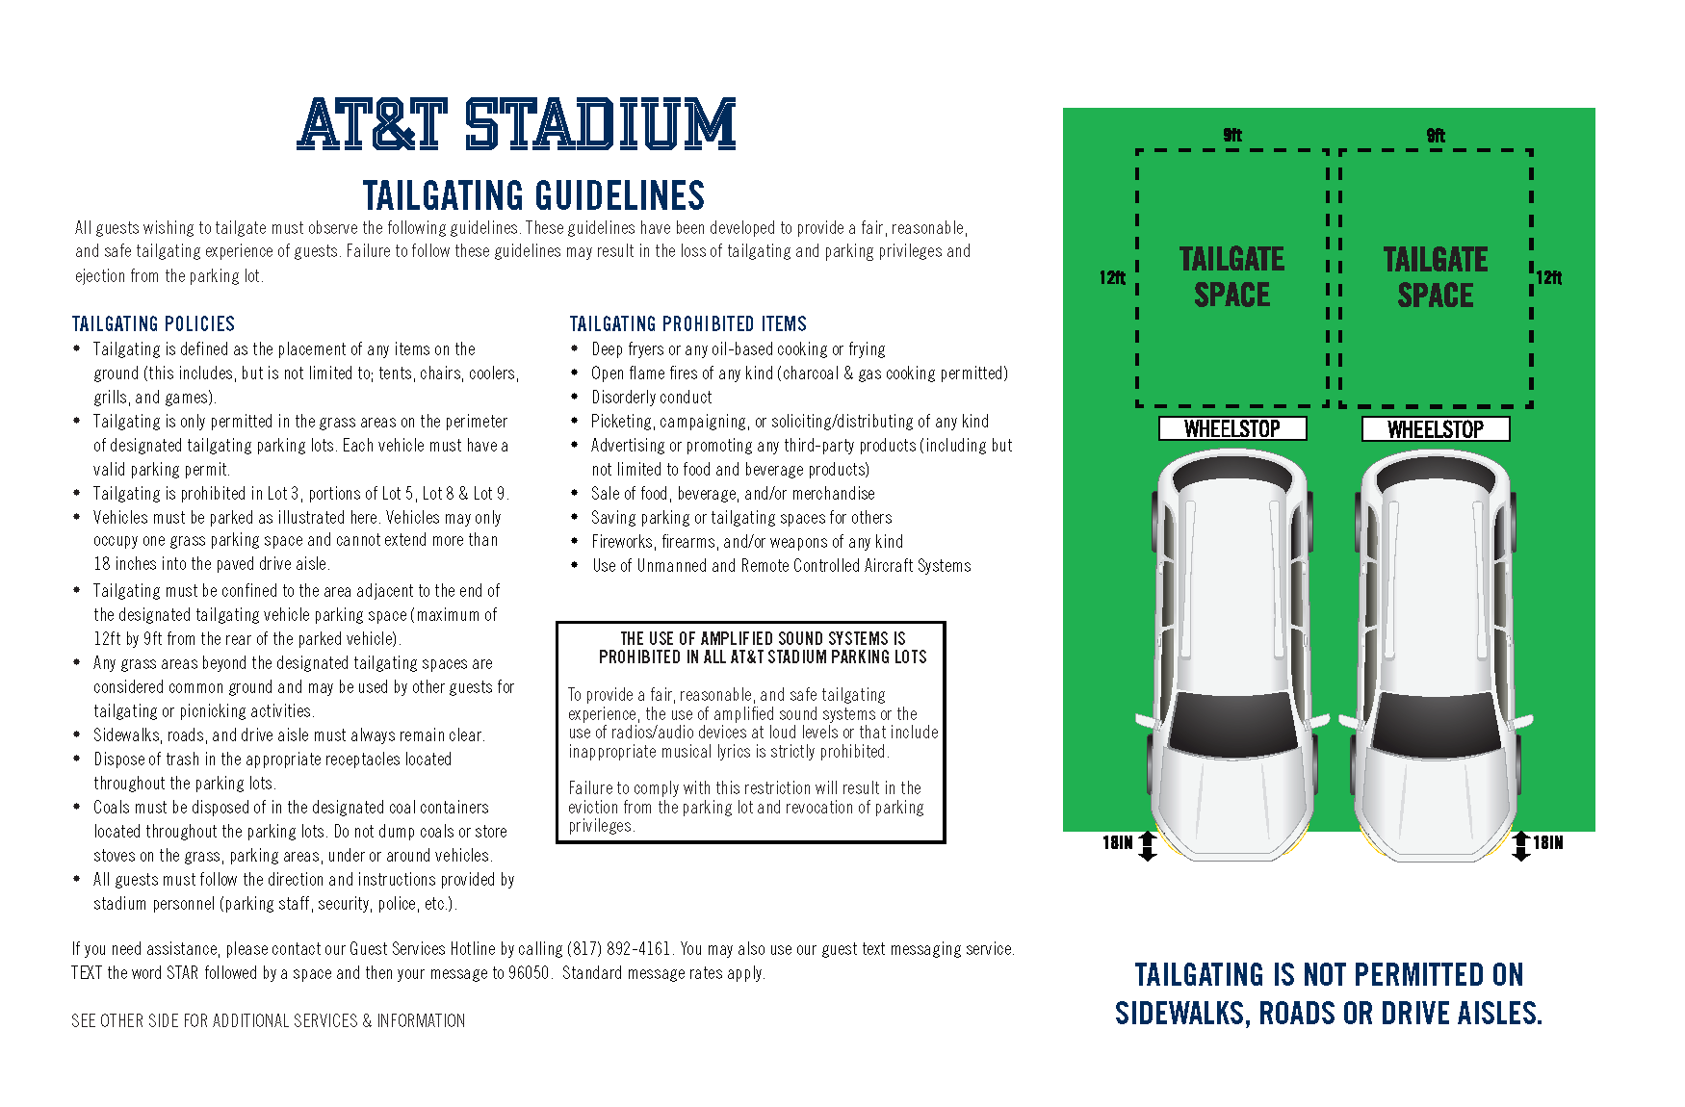
Code of Conduct

AT&T Stadium Management is committed to creating a safe, comfortable and enjoyable experience for our guests. Our staff will proactively support an environment free from the following behaviors: Abusive, foul or disruptive language and obscene gestures, intoxication or other signs of impairment related to alcohol consumption, fighting, taunting or threatening remarks or gestures, sitting in a location other than the guest’s ticketed seat, displays of affection not appropriate in a public setting, obscene or indecent clothing, any disruption to the progress of the event by the guest’s actions.

